****

**Site Cleanup and Reinstatement at Vardisubani, Entrance to Telavi (Telavi Municipality)**

**Sub-Project Environmental and Social Screening and**

**Environmental Management Plan**

**WORLD BANK FINANCED**

**REGIONAL DEVELOPMENT PROJECT**

**Tbilisi, Georgia**

**August 2014**

**Environmental Screening**

Sub-project (SP) area is located is Telavi municipality, Kakheti region, Eastern Georgia. The site represents 2 km long strip of the road connecting Vaziani to Telavi (Vaziani-Gombori-Telavi road). The section includes the area between km 65 – km 67 located on the left bank of the Matsantsara river, in the limits of vil.Vardisubani. It borders with village Vardisubani from the North, Telavi - from the East, Matsantsara River from the South. The area is inclined in North to East direction (Slope 4-60).

The abovementioned site was a place of disposal of debris generated as a result of construction works under several SPs pf the Regional Development Project (RDP) being implemented in Telavi. Disposal of debris was taking place on the basis of the written consent of Telavi Municipality Gamgeoba. Apart from the debris generated as a result of construction works under these SPs, this area has been used generally as a place for disposal of various types of construction waste, including an asbestos-containing waste.

Present SP will finance clean-up and reinstatement of the area; including removal of asbestos-containing waste to Telavi municipal landfill with relevant safety measures in place; upgrading the site and harmonizing it with surroundings; and reinforcement the Matsantsara river banks. More specifically, the works will include: collecting, packing, and out-transporting of waste; stripping and temporary storing of the topsoil where appropriate; arrangement of hydrotechnical structres; arrangement of gabions along the river bank; grading the area; reintroduction of the topsoil and biological recultivation (seeding with grass, planting). For protection of the river banks, 20 m long and about 3m high gravity support wall with be provided. The toe of the wall will be protected with boulders. The main structure – built of 1x1x2.5m, 1x1x2.0m and 1x1x1.5m gabions.

An enviornmental audit of the SP site was comissioned by MDF and carried out by Gamma Consulting company earlier in 2014. Present ER and EMP are based on the findings and recommendation profided through the audit.

**(A) IMPACT IDENTIFICATION**

|  |  |
| --- | --- |
| Has sub-project a tangible impact on the environment? | The SP has a tangible positive impact on the environment. . |
| What are the significant beneficial and adverse environmental effects of sub-project? | Positive environmental impacts of the SP are clean-up of waste, its adequate disposal, and reinforcement of river banks that will discontinue pollution of water and soil, decrease health hazards for local population, improve aesthetic appearance of one of the main motor-road entrances to Telavi, and will result in decreased erosion of river banks as well as lesser turbidity of its water.  Potential risks of this SP are improper sourcing of rocks for the arrangement of gabions and traffic congestion in case Vaziani-Gombori-Telavi road section nearby the SP site is blocked with poorly stockpiled construction materials and/or collected waste. |
| May the sub-project have any significant impact on the local communities and other affected people? | SP implementation will not require any type of resettlement.  It will have positive social impacts in terms of decreased health hazards and improved aesthetic appearance of the area near Vardisubani village.  At post construction stage the area will be visually attractive and clean. The negative visual impact on people using the road and local residents caused by waste dumped and scattered along the road will be eliminated |

**(B) MITIGATION MEASURES**

|  |  |
| --- | --- |
| Were there any alternatives to the sub-project design considered? | Objective of the SP is to clean up and reinstate the selected polluted site and no alternatives have been considered therefore.  As for the technical alternatives, using gabions were considered as preferable option compared to concrete wall or blocks. Visually the gabions better merge with environment, it reach maximum firmness and stability, as ground which fills gaps between the rocks gets accumulated and vegetation starts to grow. Water flow in the river during high water of the scale manageable by the gabions. Besides the gabions are cheaper compared to other bank stabilization options. |
| What types of mitigation measures are proposed? | The expected negative impacts of the construction phase can be easily mitigated by keeping to the good construction and traffic management practice.  The contractor will be responsible to: use inert material (stones) from the licensed quarries only, prevent water and soil from pollution (e.g. fuel spills due to equipment failure),  avoid disturbance of population (noise, dust, emissions) through proper work/supplies scheduling, good maintenance of the construction machinery, offsite traffic management, dust control, etc.  Asbestos containing material will be disposed following to the procedures described in the EMP and in accordance with written agreement with Solid Waste Management Company of Georgia Ltd. Proper disposal of the asbestos material will be strictly controlled by MDF. |
| What lessons from the previous similar projects have been incorporated into the sub-project design? | MDF have vast experience of implementation of construction and rehabilitation projects financed by various donor organizations. Community will be informed about the planned activities and timing of works. |
| Have concerned communities been involved and have their interests and knowledge been adequately taken into consideration in sub-project preparation? | The SP has been developed in consultation with local administration as a response to the current situation.  EMP will be made available for public and discussed in a consultation meeting prior to the commencement of works. |

**(C) RANKING**

The project has been classified as environmental Category B according to the World Bank safeguards (OP 4.01) and requires Completion of the Environmental Management Checklist for Small Construction and Rehabilitation Activities.

**Social Screening**

|  |  |  |  |
| --- | --- | --- | --- |
| **Social safeguards screening information** | | **Yes** | **No** |
| 1 | Is the information related to the affiliation, ownership and land use status of the sub-project site available and verifiable? (The screening cannot be completed until this is available) |  | **\*** |
| 2 | Will the sub-project reduce people’s access to their economic resources, such as land, pasture, water, public services, sites of common public use or other resources that they depend on? |  |  |
| 3 | Will the sub-project result in resettlement of individuals or families or require the acquisition of land (public or private, temporarily or permanently) for its development? |  |  |
| 4 | Will the sub-project result in the temporary or permanent loss of crops, fruit trees and  Household infra-structure (such as ancillary facilities, fence, canal, granaries, outside toilets and kitchens, etc.)? |  |  |
| If answer to any above question (except question 1) is “Yes”, then OP/BP 4.12 Involuntary Resettlement is applicable and mitigation measures should follow this OP/BP 4.12 and the **Resettlement Policy Framework** | | | |

\*All area is municipal property only part of the site#5 area (which is on the opposite side of the main working area) is private land the presses of obtaining consent of the land owner is on-going.

**PART A: General Project and Site Information**

|  |  |  |  |  |
| --- | --- | --- | --- | --- |
| **INSTITUTIONAL & ADMINISTRATIVE** | | | | |
| **Country** | Georgia | | | |
| **Project title** | RDP Kakheti | | | |
| **Sub-Project title** | Site Cleanup and Reinstatement at Vardisubani, Entrance to Telavi (Telavi Municipality) | | | |
| **Scope of site-specific activity** | Objective of works is amelioration of construction waste disposal area (km 65-km67 section of Vaziani-Gombori-Telavi road):   * Clean-up of asbestos-containing waste; * Reinstatement of the area; * Reinforcement of Matsantsara River banks with gabions.   More specifically, the SP will finance the following types of works:  Management of the asbestos-containing waste   * Collecting and packing of the asbestos-containing waste; * Disposing hazardous waste at the Telavi solid household waste landfill.   Bank reinforcement   * Preparation of the foundation of the bank-reinforcing structures; * Installation of gabions.   Reinstatement of the territory   * Grading and compacting of non-hazardous construction waste, leveling of artificial hills, filling uppits and tranches and landscaping of the site; * Spreading the fertile soil layer on the surfaced territory (up to the design point); * Territory greening (arrangement of the herbaceous cover). | | | |
| **Institutional arrangements (WB)** | Task Team Leader:  Ahmed Eiweida,  Co-Task Team Leader:  Xiaolan Wang | | Safeguards Specialist:  Darejan Kapanadze | |
| **Implementation arrangements (Borrower)** | Implementing entity:  Municipal Development Fund of Georgia | Works supervisor:  (tbd) | | Works contractor:  (tbd) |
| SITE DESCRIPTION | | | | |
| **Name of institution whose premises are to be rehabilitated** | Telavi municipality | | | |
| **Address and site location of institution whose premises are to be rehabilitated** | SP site is located in East Georgia In Telavi municipality. Vaziani-Gombori-Telavi road (S-38) 65 – 67-km section | | | |
| **Who owns the land?**  **Who uses the land (formal/informal)?** | Municipal property | | | |
| **Description of physical and natural environment around the site** | SP area is located along Vaziani-Gombori-Telavi road, on the left bank of the Matsantsara river (which is dry always except for high water period), in the limits of vil.Vardisubani, Telavi municipality, Kakheti region, Eastern Georgia. The site borders with village Vardisubani from the North, Telavi - from the East, Matsantsara river from the South, The area is inclined in North to East direction. Slope 4-60.  Dimensions of the area are: total length 679m, minimum width 16 m, maximum 75 m. Total area 28836m2 (2.9 ha). (Waste is dumped also on the other side of the road within a small area, which is not a part of the project).  The site is located in 145m from Vaziani-Telavi and Akhmeta-Telavi crossroad. In 40m from the farthest border of the site located is a small inert material production facility. Along the site, parallel to the road (in 50m from the carriageway) located is 1.5 m wide and 0.8-1.0m deep trench. Slopes and bottom of the trench are vegetated with shrubs and grass.  According to air quality analysis (N2, O2, Ar, CO2, CO, CH4 were measured) air quality within the study area is safe for human health.  Most part of the study area is under anthropogenic influence, thus the soil cover is not highly valuable. Soil quality examination proved that cadmium content in all samples is below detection limit of the method. Lead, nickel, copper and zinc content does not exceed the relevant maximum permissible concentrations, while arsenic is slightly above allowable limit, but within the local background limits. Total petroleum hydrocarbon content is very low and/or below detection limit of the method.  Ground water aquifer in Telavi and vil.Vardisubani is deep (30-40m).  The territory is located in 9th seismic zone (MSK64 scale). Dimensionless coefficient of the seismicity for the territory is – 0.31.  Main source of noise is traffic. Noise measurement shows that traffic related noise is within acceptable range even at 10m distance from the road.  Vegetation is poor – several individual trees and bushes, low productivity plants are registered within the project area.  No traces of animals, nests or habitats were detected during the visual audit. It is less probable that design territory is used by small mammals for migration. Riverbed is dry most time of the year, which means that ichthyofauna is non-existent.  Physical environment on-site is described below:  Site 1 (the narrowest section of the area). 1000mm concrete drainage pipe arranged under the road is registered. Perpendicula to the pipe 50mm and 100mm stell waterpipes and electric cable with plastoic insulation are running.  Sites 2 and 3 Visual inspection does not reveal presence of any infrastructure. There is internal road across the section which runs from the main road up to the Matsantsara riverbed.  Site 4. In 30 m from upper border of this site, in 15 m from Vaziani-Telavi motorway, double-hatch buried steel tank is registered. (Approximate capacity 25-30 m3). Both hatches are open. Small volume of water and construction waste is visible in the tank. Besides, in 6 m from the road there is a 30-40m2 pond with waste water frm the inert-material processing unit. At some distance from the pond, two parallel, large diameter (500mm) steel pipes are observed. These pipes presumably belong to former or current water supply system. This issue must be specified with the Tevali municipality.  Site 5. No infrastructure is registered. Local importance road runs along the eastern border of the site. | | | |
| **Locations and distance for material sourcing, especially aggregates, water, stones?** | Supply of materials (e.g. inert materials) is possible from the nearest quarries, existing alongside the riv. Tudroskhevi. The distance to these is approximately 2.5-5km.  Taking into account small volume of works, it is less presumable that contractor will decide to arrange quarries of its own. However, if contractor already has license for mining, he may use “own materials”.  Considering specificities of the design works, use of water will be required during collection-wrapping of asbestos-containing materials, territory watering during the ground works, in order to minimize dust propagation and for watering the territory after its renovation and greening. Technical water will be supplied with cisterns, as for the drinking water – bottled water or the water from the local supply system will be used (the distance to the nearest living house is 50 m.)  The seeds of herbaceous plants will be purchased in Telavi (approximate distance 400 m).  Bricks and cement will be purchased from the licensed supplier. | | | |
| LEGISLATION | | | | |
| **National & local legislation & permits that apply to project activity** | The Georgian Law on Licensing and Permits establishes types of activity regulated by licenses and permits, defines comprehensive list of licenses and permits and determines rules for issuance, amendment and termination of licenses and permits. As the SP envisages renovation-rehabilitation of the territory and construction of new structures is not planned, implementation of works does not require acquisition of any license or permit. Collection-removal-final disposition of asbestos-containing materials must be implemented by a licensed contractor.  The Georgian Law on “Public Health” states that each person on the state’s territory is obliged not to implement such activities, which create threat of spreading of contagious and non-contagious diseases, create risks associated with health. Considering that SP involves collection and disposition of asbestos-containing materials, workers on-site must wear uniforms and protective gear, the site has to be watered when asbestos-containing materials are handled, collected hazardous waste must be immediately packed and piled up for transportation in a designated location on-site. .  The Georgian Law on “Water” – regulates legal issues related to water protection, study and use. The design territory is located near the riv. Matsantsara. Although the river only flows during the high-water period, during the project implementation all measures must be implemented in order to exclude risks of riverbed pollution.  During the project implementation, there is a risk of fertile soil layer damage and deterioration of the soil quality; considering disposition of the territory, development of erosive processes is also possible. In compliance with the Georgian Law on Soil Protection and the order #2-277 (25.11.2005) of the Minister of Agriculture on approving “Recommendations for Complex Measures for Soil Protection from the Erosion” – the SP will undertake bank reinforcement using gabions and arrangement of water-abstraction channel along the territory, on the side of the road.  Taking into account location of the design site, order #4 (18.01.2002) of the Minister of Urbanization and Construction on affirming “Rules for Regulation and Engineering Protection of Georgian Sea and River Banks” and the Georgian Law on “Regulation and Engineering Protection of Georgian Sea, Reservoir and River Banks” must also be considered.  The SP envisages reinstatement of a site of waste disposal and therefore following must be taken into consideration:  1) Order #113 (27.05.2005) of the Minister of Environment and Natural Resources’ Protection on affirming regulation on “Removal, Sotrage, Use and Recultivation of the Fertile Soil Layer” and  2) Resolution of the GoG #424 (31.12.2013) on affirming technical reglament on “Removal, Sotrage, Use and Recultivation of the Fertile Soil Layer”. These documents consider issues of land resources protection and rational use and issues related to removal, sotrage, use and recultivation of the fertile soil layer during different activites. According to the regulation, restoration of degraded soil fertility must be implemented using recultivation (technical and biological) methods.  Transportation of construction waste to the landfill or final disposition of inert materials generated during the ground works at the pre-selected territory must be agreed with the local municipality and Solid Waste Management Company LTD. in written. | | | |
| **PUBLIC CONSULTATION** | | | | |
| When / where the public consultation process will take /took place | EMP will be discussed with beneficiary community prior to the commencement of works. | | | |
| **ATTACHMENTS** | | | | |
| Attachment 1: Site map and pictures, General Plan  Attachment 2: Record on public consultation (to be provided)  Attachment 3: Agreement(s) on waste disposal (to be provided) | | | | |

**PART B: safeguards information**

|  |  |  |  |
| --- | --- | --- | --- |
| **ENVIRONMENTAL /SOCIAL SCREENING** | | | |
| Will the site activity include/involve any of the following? | **Activity/Issue** | **Status** | **Triggered Actions** |
| 1. Building rehabilitation | [ ] Yes [ ] No | See Section **A** below |
| 1. New construction | [ ] Yes [ ] No | See Section **A** below |
| 1. Individual wastewater treatment system | [ ] Yes [ ] No | See Section **B** below |
| 1. Historic building(s) and districts | [ ] Yes [ ] No | See Section **C** below |
| 1. Acquisition of land[[1]](#footnote-1) | [ ] Yes [ ] No | See Section **D** below |
| 1. Hazardous or toxic materials[[2]](#footnote-2) | [ ] Yes [ ] No | See Section **E** below |
| 1. Impacts on forests and/or protected areas | [ ] Yes [ ] No | See Section **F** below |
| 1. Handling / management of medical waste | [ ] Yes [ ] No | See Section **G** below |
| 1. Traffic and Pedestrian Safety | [ ] Yes [ ] No | See Section **H** below |

**PART C: Mitigation measure**

|  |  |  |
| --- | --- | --- |
| **ACTIVITY** | **PARAMETER** | **MITIGATION MEASURES CHECKLIST** |
| **0**. General Conditions | Notification and Worker Safety | 1. The local construction and environment inspectorates and communities have been notified of upcoming activities 2. The public has been notified of the works through appropriate notification in the media and/or at publicly accessible sites (including the site of the works) 3. All legally required permits have been acquired for construction and/or rehabilitation 4. The Contractor formally agrees that all work will be carried out in a safe and disciplined manner designed to minimize impacts on neighboring residents and environment. 5. Workers’ PPE will comply with international good practice (always hardhats, as needed masks and safety glasses, harnesses and safety boots) 6. Appropriate signposting of the sites will inform workers of key rules and regulations to follow. |
| **A.** General Rehabilitation and /or Construction Activities | Air Quality | 1. Demolition debris shall be kept in controlled area and sprayed with water mist to reduce debris dust 2. During pneumatic drilling/wall destruction dust shall be suppressed by ongoing water spraying and/or installing dust screen enclosures at site 3. The surrounding environment (sidewalks, roads) shall be kept free of debris to minimize dust 4. There will be no open burning of construction / waste material at the site 5. There will be no excessive idling of construction vehicles at sites 6. Truck loads should be confinement and protected with lining. |
| Noise | 1. Construction noise will be limited to restricted times agreed to in the permit 2. During operations the engine covers of generators, air compressors and other powered mechanical equipment shall be closed, and equipment placed as far away from residential areas as possible 3. The machinery should move only along the preliminarily agreed route; 4. The maximum allowed speed should be restricted; 5. Proper technical control and maintenance practices of the machinery should be applied; 6. No-load operations of the vehicles and heavy machinery are not allowed. Proper mufflers will be used on machinery. |
| Water Quality | 1. Contractor will be required to organize and cover material storage areas. The material storage sites should be protected from washing out during heavy rain falls and flooding through covering by impermeable materials. Appropriate erosion and sediment control measures will be established such as e.g. hay bales and / or silt fences to prevent sediment from moving off site and causing excessive turbidity in nearby streams and rivers; 2. Contractor will plan all excavations, topsoil and subsoil storage so as to reduce to a minimum any runoff; 3. Revision of vehicles will be required to ensure that there is no leakage of fuel and lubricating materials. All machinery will be maintained and operated such that all leaks and spills of materials will be minimised. Daily plant checks (Vehicle Maintenance Procedure) will be undertaken to ensure no leaks or other problems are apparent. Vehicle maintenance, cleaning, degreasing etc will be undertaken in designated areas, of hard-standing, not over made ground. Maintenance points will not be located within 50m of any watercourse; 4. Lubricants, fuel and solvents should be stored and used for servicing machinery exclusively in the designated sites, with adequate lining of the ground and confinement of possible operation and emergency spills. Spill containment materials (sorbents, sand, sawing, chips etc.) should be available on construction site; 5. Wet cement and/or concrete will not be allowed to enter any watercourse, pond or ditch. |
| Waste management | 1. Waste collection and disposal pathways and sites will be identified for all major waste types expected from demolition and construction activities. 2. Mineral construction and demolition wastes will be separated from general refuse, organic, liquid and chemical wastes by on-site sorting and stored in appropriate containers. 3. Construction waste will be collected and disposed properly by licensed collectors 4. The records of waste disposal will be maintained as proof for proper management as designed. 5. Whenever feasible the contractor will reuse and recycle appropriate and viable materials (except asbestos) |
|  | Material supply | 1. Use existing plants, quarries or borrow pits that have appropriate official approval or valid operating license. 2. Obtain licenses for any new quarries and/or borrowing areas if their operation is required; 3. Reinstate used sections of quarries and/or borrowing areas as extraction proceeds on or properly close quarries if extraction completed and license expired; 4. Haul materials in off peak traffic hours; 5. Place speed regulating, diverting, and warning signs for traffic as appropriate. |
|  | Protection of trees along the roads | a) Trees along the road must be protected from cutting or unintentional damage;  b) Cut of tree branches and removal vegetation covered the ditches and disposal of cut vegetation must be approved by local (municipal) governing bodies in written. |
| **E**. Toxic Materials | Asbestos management | 1. asbestos located on the SP site shall be marked clearly as hazardous material; 2. asbestos will be appropriately contained and sealed to minimize exposure; 3. The asbestos prior to removal will be treated with a wetting agent to minimize asbestos dust; 4. Asbestos will be handled and disposed by skilled & experienced professionals equipped with special PPE; 5. If asbestos material is stored temporarily, the wastes should be securely enclosed inside closed containments and marked appropriately. Security measures will be taken against unauthorized removal from the site; 6. The removed asbestos will not be reused; 7. The asbestos will finally disposed on the nearest official landfill in accordance with written agreement with MoENRP and "Solid Waste Management Company of Georgia" Ltd. |
| **H** Traffic and Pedestrian Safety | Direct or indirect hazards to public traffic and pedestrians by construction  activities | (a) In compliance with national regulations the contractor will insure that the construction site is properly secured and construction related traffic regulated. This includes but is not limited to   * Signposting, warning signs, barriers and traffic diversions: site will be clearly visible and the public warned of all potential hazards * Traffic management system and staff training, especially for site access and near-site heavy traffic. Provision of safe passages and crossings for pedestrians where construction traffic interferes. * Adjustment of working hours to local traffic patterns, e.g. avoiding major transport activities during rush hours or times of livestock movement * Active traffic management by trained and visible staff at the site, if required for safe and convenient passage for the public. * Ensuring safe and continuous access to office facilities, shops and residences during renovation activities, if the buildings stay open for the public. * To arrange speed bumps to reduce vehicle speed and appropriate signs (road narrows/mind pedestrians) in agreement with local traffic police. |

**PART D: Monitoring Plan**

|  |  |  |  |  |  |  |  |
| --- | --- | --- | --- | --- | --- | --- | --- |
| **Activity** | **What**  (Is the parameter to be monitored?) | | **Where**  (Is the parameter to be monitored?) | **How**  (Is the parameter to be monitored?) | **When**  (Define the frequency / or continuous?) | **Why**  (Is the parameter being monitored?) | **Who**  (Is responsible for monitoring?) |
| **CONSTRUCTION PHASE** | | | | | | | |
| **Supply with construction materials during Arrangement of gabions and water diversion culvert** | Purchase of construction materials from the officially registered suppliers | | In the supplier’s office or warehouse | Verification of documents | During conclusion of the supply contracts | To ensure technical reliability and safety of infrastructure | MDF,  Construction supervisor |
| **Asbestos containing material collection, packing and removal** | * Fencing the area; * Installation of warning signs; * Prohibitions of unauthorised access; * Equipping with PPE: helmet, googles, gloves, respirators, disposable overalls, rubber boots; use of the PPE by asbestos handling staff; * Watering of the area prior to collection of asbestos containg materials in order to avoid air pollution with asbestos fiber while handling; * Prohibition of air blowing, dry sweeping, eating/drinking in the area, prohobition of unauthorized access during works, leaving the controlled area in ‘dirty’ overalls. * Material packaging control; * Compliance with transportation rules of loading-unloading of asbestos-containing material. | | Perimeter of the project area | Unscheduled inspection, visual control and inspection | In the course of works | Population and Workers health and safety | MDF,  Construction supervisor |
| **Disposal of asbestos containing material**. | * Compliance of the trench dimensions with relevant standards; * Keeping to the rules/ requirements set for safe disposal of asbestos containing material in the trench. | | Landfill area – final disposal site | Inspection | Disposal of the waste on the landfill site | Community, environment – health and safety. | MDF,  Construction supervisor |
| **Earthworks** | * Removal of topsoil; * Temporary storage within the agreed area with relevant protection measures (protection from spreading by wind, scouring by surface runoff, ramming); * Spreading of the stripped soil over the area after completion of works. | | Project site | Inspection | During earthworks | Avoidance of project site and adjacent area pollution | MDF,  Construction supervisor |
| **Land grading** | * Dust suppression measures; * Avoidance of material/waste dumping in the riverbed; * Proper technical maintenance of machinery | | SP site | Inspection | Periodically in the course of works, in case of complaints | Reduce dust and emission related nuisance/impact; Avoidance of riverbed blockage; Avoidance of pollution with spilled oil/fuel from machinery. | MDF,  Construction supervisor |
| **Protection of trees** | * Avoidance of damage during the site amelioration works; * Avoidance of dumping material in the critical root zone; * Protection of trees after completion of works. | | The area within the SP site where trees are growing | Inspection | In the course of works | Avoidance of the tree damage | MDF,  Construction supervisor |
| **Disposal/storage of material** | * Storage of inert (construction) material in specially allocated area. | | Material storage area | Inspection | Periodically in the course of works, in case of complaints | Avoidance of the risk of blpockage of the site and adjacent area and avoidance of related problems (hinderance of motor and pedestrian traffic, violation of safety safety). | MDF,  Construction supervisor |
| **Waste material management** | * Storage of inert (construction) waste in specially allocated area; * Registration of the quantity of reusable material; * Disposal of non-hazardous access material on-site through grading, compacting and levelling. | | * Material disposal area; * Area owned by contractor. | Inspection | Periodically in the course of works, in case of complaints | Reduce the risk of pollution of adjacent area with solid waste. | MDF,  Construction supervisor |
| **Traffic disruption and limitation of pedestrian access** | * Installation of traffic limitation/diversion signage; * Storage of construction materials and temporary placement of construction waste in a way preventing congestion of access roads | | At and around the construction site | Inspection | In the course of construction works | Prevent traffic accidents;  Limit nuisance to local residents | MDF,  Construction supervisor |
| **Workers’ health and safety** | * Provision of uniforms and safety gear to workers; * Informing of workers and personnel on the personal safety rules and instructions for operating machinery/equipment, and strict compliance with these rules/instructions | | Construction site | Inspection | Unannounced inspections in the course of work | Limit occurrence of on-the-job accidents and emergencies | MDF,  Construction supervisor |
| **OPERATION PHASE** | | | | | | | |
| **Technical status of gabions** | Maintaining good technical status of gabions | Within the boundaries of the project site | | Visual control | Periodically, for 2 years after completion of Works. After high water events. | Bank stability preservation | Telavi municipality |

# Attachment - Maps

# C:\Users\njangulashvili\Desktop\RDP_Kakheti\თელავი-ნარჩენების პოლიგონი\Telavi_06.06.14\tomi 3_garemoze zemoqmedebis gegma\ნაგავი ორთო.png

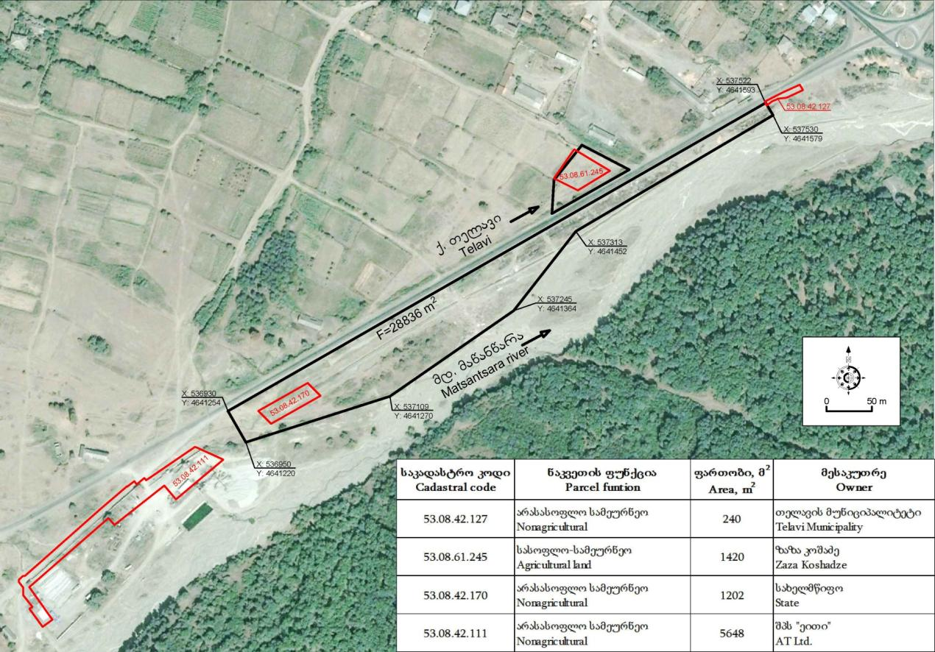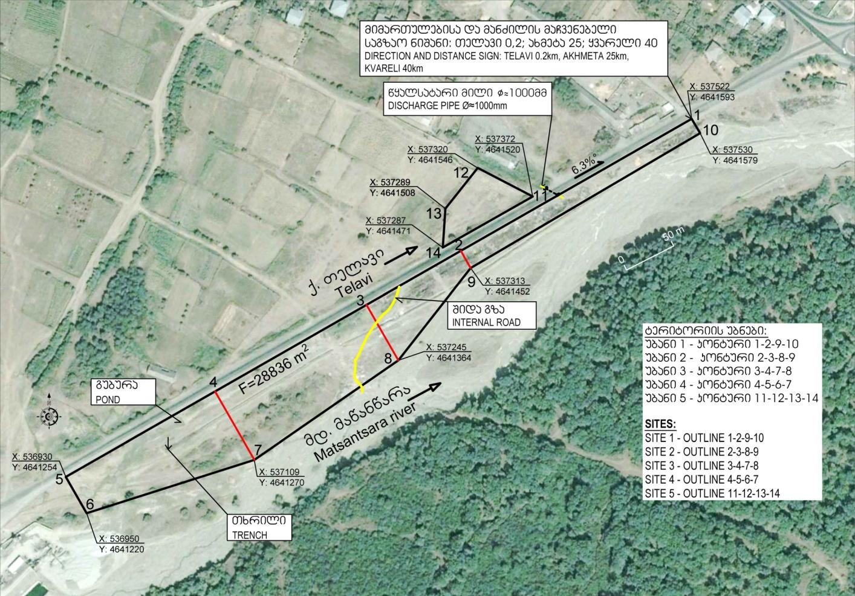

,,, **Layout of the area with indication of coordinates and objects available on the site**



**Land owneship –cadastral data**

|  |
| --- |
| C:\Users\njangulashvili\Desktop\RDP_Kakheti\თელავი-ნარჩენების პოლიგონი\Telavi_06.06.14\tomi 3_garemoze zemoqmedebis gegma\ნაგავი 2_001.png |

**Land owneship –cadastral data**

|  |
| --- |
| C:\Users\njangulashvili\Desktop\RDP_Kakheti\თელავი-ნარჩენების პოლიგონი\Telavi_06.06.14\tomi 3_garemoze zemoqmedebis gegma\ნაგავი 1_001.png |

|  |
| --- |
| C:\Users\njangulashvili\Desktop\RDP_Kakheti\თელავი-ნარჩენების პოლიგონი\Telavi_06.06.14\tomi 3_garemoze zemoqmedebis gegma\ნაგავი 3_001.png |

|  |
| --- |
| C:\Users\njangulashvili\Desktop\RDP_Kakheti\თელავი-ნარჩენების პოლიგონი\Telavi_06.06.14\tomi 3_garemoze zemoqmedebis gegma\ნაგავი 4_001.png |

# Attachment - Photoos

|  |  |
| --- | --- |
| D:\SHURA_DESKTOP\Vardisubani-Telavi\Copy of IMG_1043.jpg  Road sign in 145m from the crossing – lower side of the project area | D:\SHURA_DESKTOP\Vardisubani-Telavi\IMG_1044.jpgSite 11 - Typical levelled are with shrub and grass vegetation |
| D:\SHURA_DESKTOP\Vardisubani-Telavi\IMG_1047.jpg  Site 1– Drainabe pipecap in the mid section of the area; 50 and 100mm water pipes and electric cable (with white insulation)in the middle area. | D:\SHURA_DESKTOP\Vardisubani-Telavi\IMG_1049.jpgSite 12– Typical waste in the area |
| D:\SHURA_DESKTOP\Vardisubani-Telavi\IMG_1048.jpg  Site 12– Typical waste: ceramic tiles, asbestosconcrete and tile fragments. White insulation material on the foreground. | D:\SHURA_DESKTOP\Vardisubani-Telavi\IMG_1052.jpgSite 2– Typical construction waste |
| D:\SHURA_DESKTOP\Vardisubani-Telavi\IMG_1066.jpg  Site 2 – Internal road; construction waste piles along the road. | D:\SHURA_DESKTOP\Vardisubani-Telavi\IMG_1068.jpgSite 2 – Fragments of asbestos-cement tiles. |
| D:\SHURA_DESKTOP\Vardisubani-Telavi\IMG_1069.jpg  Site 3 – Debris of asbestos cement tiles dumped along the internal road. | D:\SHURA_DESKTOP\Vardisubani-Telavi\IMG_1059.jpgWarning sign – informing about penalty set for dumping rubbish and construction waste in the area |
| D:\SHURA_DESKTOP\Vardisubani-Telavi\IMG_1064.jpg  1.5 m wide, o,8m deep trench along the site. | D:\SHURA_DESKTOP\Vardisubani-Telavi\IMG_1077.jpg  Site 4 – typical landform. No construction or other waste –registered. |
| D:\SHURA_DESKTOP\Vardisubani-Telavi\IMG_1073.jpg  Site 4 – small pond (surface area 40m2) | Site 4 - Ø 500mm steel pipes  500mm steel pipes |
| D:\SHURA_DESKTOP\Vardisubani-Telavi\IMG_1087.jpg  Inert material production facility west to the project site. Gully formed by waste water flow from production site. | Local importance road east to the Site 5. |
| Site 5 – General view. Area located north to construction waste dumpsite, another side of S-38 road. | Site 5 – Typical waste dumped in the limits of the site. Asbestos cement roofing tiles dominate. |

|  |
| --- |
| **Attachment - General PlanC:\Users\njangulashvili\Desktop\RDP_Kakheti\თელავი-ნარჩენების პოლიგონი\Telavi_06.06.14\tomi 2.2_ketilmotskoba_04.06.14\2.2_ketilmotskoba_A3_GEO-ENG_007.png** |

1. Land acquisitions includes displacement of people, change of livelihood encroachment on private property this is to land that is purchased/transferred and affects people who are living and/or squatters and/or operate a business (kiosks) on land that is being acquired. [↑](#footnote-ref-1)
2. Toxic / hazardous material includes but is not limited to asbestos, toxic paints, noxious solvents, removal of lead paint, etc. [↑](#footnote-ref-2)