Loan Number: 2655-GEO (SF)

Reporting period: July-December, 2014

GEORGIA: GEORGIAN SUSTAINABLE URBAN TRANSPORT INVESTMENT PROGRAM, Tranche 1

(Financed by the Asian Development Bank)

Prepared by: Nino Nadashvili, Environmental Safeguards Specialist
Environmental and Resettlement Unit, Municipal Development Fund (MDF)
Tbilisi, Georgia

Endorsed by: David Tabidze, Head of Environmental and Resettlement Unit
Municipal Development Fund (MDF)
Tbilisi, Georgia

January 15, 2015

ABBREVIATIONS

ADB Asian Development Bank
EA Executing Agency
EARF Environmental Assessment and Review Framework
EIA Environmental Impact Assessment
EIP Environmental Impact Permit
EMP Environmental Management Plan
EPSM Engineering Procurement and Construction Management
GoG Government of Georgia
SUTIP Georgian Sustainable Urban Transport Investment Program
IA Implementing Agency
IEE Initial Environmental Examination
MDF Municipal Development Fund
MFF Multi-tranche Financing Facility
MoENRP Ministry of Environmental and Natural Resources Protection
MoRDI Ministry of Regional Development & Infrastructure
SSEMP Site-Specific Environmental Management Plan

Table of Contents

1. PART I. INTRODUCTION 4
1.1 Preliminary Information 4
1.2 Construction activities and projects’ progress during the reporting period 7
1.3 Changes of project organization and environmental management team 8
1.4 Relationship with contractors, owner, lender etc 9
2. PART II: ENVIRONMENTAL MONITORING 9
3. PART III: ENVIRONMENTAL MANAGEMENT 12
3.1 The environmental management system, site-specific environmental management plan (SEMP) and work plans 13
3.2 Site Inspection and audits 13
3.3 Noncompliance notice and corrective actions 13
3.4 Consultation and Complaints 18
4. A n n e x e s 19
4.1 Monitoring Data 20
4.2 Photographs 25
4.3 Implementation report on the environmental impact assessment (EIA)/initial environmental examination (IEE)/Site Specific Environmental Management Plan (SEMP) mitigation requirements 27

PART I. INTRODUCTION

Preliminary Information

Projects’ Background

Upgrading and improvement of local transport and transport-related infrastructure plays a significant role in the development of Georgia infrastructure. To this effect a number of important activities have been implemented and financed from the budget of Georgia and from other sources.
Recently several significant programs, financed through state budget, loans and grants, have been implemented with this regard.

On 05 August, 2010 MFF - Sustainable Urban Transport Investment Program Tranche 1 Loan and Project agreements were signed between Georgia and Asian Development Bank. MFF-Sustainable Urban Transport Investment Program – Tranche 1 (SUTIP T1) includes (i) Transport Infrastructure Improvement; (ii) Institutional Capacity Development and (iii) Project Management Facility components.

The program will provide efficient, reliable and affordable urban transport infrastructure and services, thereby increase economic growth potential and competitiveness of urban communities, and improve livelihoods of over 1.5 million people (approx. 35% of Georgian population). The program will also: (I) improve urban, environment and communities’ access to economic opportunities and to public and social services; (II) promote efficient and sustainable urban transportation; and (III) generate income and employment opportunities.

The environment classification for Tranche 1 is Environmental Category B, as all subprojects under SUTIP 1 were classified as category B which will not have significant irreversible or permanent negative environmental impacts during or after construction and requires preparation of Initial Environmental Examination (IEE). The environmental categorization of subprojects was conducted using ADB’s Safeguard Policy Statement (2009). Required environmental assessments of SPs are conducted and IEEs are prepared in accordance with Environmental Assessment and Review Framework approved for SUTIP 1 in May, 2010.

Projects’ Area

Sustainable Urban Transport Investment program Tranche 1 includes several projects in the different municipalities of Georgia. Program aims efficient, reliable and affordable urban infrastructure development and service improvement. In effect, urban transport service will be improved, and the level of different types of public and social services will be increased.

Among the Sustainable Urban Transport Investment program Tranche 1 subprojects, which are ongoing now, are:

- Tbilisi Metro Line 2 and Creation of University Station EPCM;
- Anaklia coastal improvement EPCM (Phase 1);

Tbilisi Metro extension EPCM: (1)

Tbilisi suffers from traffic congestion and air and noise pollution, loss of green areas and degradation of historical buildings and monuments. Serving 250,000 passengers daily, the Tbilisi Metro is playing a significant role in the urban transport system and can serve as the backbone of the city’s network. Tbilisi Municipality is now exploring options for expanding the network. A first phase is planned to extend the line to the station “University” at Saburtalo district, where there is a large population, significant number of students and high traffic flow. The construction of the “Delisi-University” section of the metro started in 1985 but ceased in 1993 for financial and technical reasons. In 1998 construction resumed and “Vaja Pshavela” station was opened in 2000 with only one way in operation. The remaining tunnel has been bored up to the university station, including the station shell, escalator shaft and the exits. This Project aims to resume and complete the construction of the metro tunnel along Vaja Pshavela Avenue and the “University” subway station, to benefit more than 150,000 people and increase ridership of the metro network. Total length of metro station line is 2.2km.

The EPCM consultant (Euroestudios) has been fielded in early August 2012. Geological surveys and investigations of the existing tunnel have been completed and used as a basis for the detailed design which has been submitted in December 2012.

The international independent metro specialist recruited by MDF provided comments which have been addressed by the EPCM consultant. MDF with the guidance of the independent metro specialist confirmed in June 2013 that the creation of the emergency exit recommended by the EPCM consultant is necessary and will be implemented. ADB confirmed the emergency exit is required according to international standards and best practices. The detailed design has been endorsed by MDF after all comments from Tbilisi Transport Company, MDF and ADB have been incorporated. ADB has no further comments on the detailed design.

The civil works tender was first advertised in June 2014. Bid evaluation report was timely prepared by MDF with the support of the ADB project team. However, as none of the bids were technically substantially responsive, ADB Procurement Committee recommended rebidding. Invitation for bids was advertised on 14 November 2014, and deadline for submission of bids is on 23 January 2015.

Anaklia coastal improvement EPCM (Phase 1)

Anaklia is a small town and seaside resort in western Georgia. It is located in the Samegrelo-Zemo Svaneti region, at the place where the Enguri River flows into the Black Sea, near the administrative border with Abkhazia. Anaklia is supposed to become a tourism center in Georgia. Anaklia infrastructure development and rehabilitation plan was announced by the Government of Georgia. Erosion processes take place on various pleases at Georgian Black Sea coastal line and Anaklia is one of them. Today this process is seriously destroyed coastline.

The project aims at Anaklia shoreline rehabilitation, restoration of the full profile of beaches to the possible limits (which is necessary for wave breaking and suppression of its power and assigns to the beach a function of bank protecting structure), selection of the most optimum types and design of hydro-technical coast protecting structures.

Coastal protection structure of underwater breakwaters is totally composed with 6 units (for phase 1) constructed from 5 Ton and 10 Ton tetrapods. The space between one to another breakwaters units is 90m but space between second one to third one (from Enguri river mouth to Tikori river mouth direction) is 100m. The length of first underwater breakwater (from Enguri river mouth to Tikori river mouth direction) is 200m, from No.2 to No.6 – the spacing is 300m. Therefore, total length of underwater breakwater is 1,700m. Length of artificial nourishment is 2,300m. Amount of Sand for phase1 is 129,000㎥. The area of 300m length from river mouth to start point, where artificial nourishment has to be started, will be covered by armor stones to prevent erosion against incident wave. Total Width of artificial nourishment is 60m, from beach line to land side is 40m and forward to seaside is 20m. Slope of beach line will be composed with 1:20. Enguri river Revetment will be performed from the river mouth (where is located a marina) to starting point of artificial nourishment. The distance will be about 300m.

Infrastructure improvement will support infrastructure investments to rehabilitate, improve and expand the beach of Anaklia and will benefit accrue principally from the protection of land and infrastructure from erosion and damage, the avoidance of some other costs and increasing number of tourists. For the interventions, benefits arise from the protection of (i) rural land, (ii) houses (iii) roads and other infrastructure. Coast protection measures need to be taken to protect the unique place and landscape. The design of approximately 4 kilometers of coastal line will create a new and attractive tourist destination on the Black Sea Coast, able to be the engine of the development of the region of Zugdidi, Ganmukhuri and Anaklia.
Significant delays have been experienced in the first months of project implementation and mitigation measures had been taken and agreed between the Engineer, the Contractor and MDF. The delays are currently being caught up but the works are still going at a slow pace. The completion date was extended twice, mostly due to bad weather conditions in winter season and the incapacity of the contractor to mobilize all necessary equipment for marine works. The works are now anticipated to be completed in April 2015. The works will be monitored according to this revised construction schedule, and MDF stated that no other time extension will be given. The contractor guaranteed that new marine equipment (floating crane and barges for tetrapod laying) will be on site no later than December, 2014. It was also found that one of the barges already mobilized is not anymore operational and should be replaced. The ADB Mission conducted in 25 Novmeber-8 December 2014, requested MDF to ensure that timely actions are taken by the Engineer and the Contractor to expedite replacement of the barge. The Mission expressed its concerns on the repeated delays in spite of close monitoring by MDF and urged the Engineer and Contractor to fulfill their commitments and to ensure the completion of the works not later than April 2015.

Construction activities and projects’ progress during the reporting period

Civil works at Tbilisi Metro extension subproject has not been started yet.

IEE document was revised by Eurostudio and all ADB comments and remarks have been reflected in IEE final document. Final version of approved IEE document is disclosed at MDF web site: http://mdf.org.ge/?site-lang=en&site-path=documents/&id=525

Civil works at Anaklia coastal improvement EPCM (Phase 1):

Civil works contract was signed with Modern Business Group LLC (Azerbaijan). The construction works started on July 24, 2013. Significant delays have been experienced in the implementation of the project. The delays are currently being caught up but the works are still going at a slow pace. The completion date was extended twice, mostly due to bad weather conditions in winter season and the incapacity of the contractor to mobilize all necessary equipment for marine works. While, all of the tetrapods are already casted and ready to be placed underwater, the marine works progress was insufficient compared to the works schedule.

During reporting period following construction work activities have been carried out by the Contractor Company – Modern Business Group Ltd (Azerbaijan):

- Sea bottom dredging – 4,366 m³;
- Filling with stones the sea bottom – 2,932 m³;
- Placing TTP units in the sea – 473;

Contractor provided following construction materials from the licensed companies:

- Sand – 210 m³;
- Crushed Rock - 230 m³;
- Natural Quarry Stone – 1,248 m³;

Contractor procures construction materials - sand aggregates, quarry stones and etc. from the following licensed companies: Crushed rock from LTD “Pulsari”, contract number HEC-09, LTD “Enguri+”-contract number -HEC-00 and “Big Energy” – contract number HEC-08/1; Sand- from company: “Lazika”, Contract number HEC-12; Natural quarry stones -from company “Grupovia” – contract number HEC-07. During reporting period 53 tons of cement was used for mentioned construction activities. Physical progress of construction works by the end of December is 54%.

The ADB Mission held in 25 Novmeber-8 December 2014, met with MDF, the engineering, procurement and construction management (EPCM) consultant (engineer) and contractor, and reviewed the progress against the implementation schedule.

Changes of project organization and environmental management team

The MDF has an overall responsibility for the Projects’ implementation. Management of environmental issues is carried out by the MDF through Environmental and Resettlement Unit, established in October 2014, when the number of Environmental and Resettlement team members has increased from 6 to 9 and currently consists of: Head of Unit, 3 environmental safeguards specialists, one safety specialist, one social safeguards specialist, 2 resettlement specialists and one ADB’s individual consultant on resettlement issues, who is also the member of Environmental and Resettlement Unit. Until October, Environmental and resettlement safeguards team was consisting of 3 environmental safeguards and 2 resettlement specialists, one of which was the ADB’s national consultant on resettlement issues. Environmental and Social Safeguards team had a Team Leader who was an advisor to Executive Director of MDF on environmental and social safeguards issues.

The Environmental and Resettlement Unit is involved in addressing of environmental and social safeguard issues throughout the entire projects’ cycles. Environmental Specialist (designated to supervise ADB projects) reviews the EIAs, EMPs, and SSEMPs of projects and carries out supervision of the performance based on approved EMPs, EIAs, and environmental standards in accordance with ADB “Safeguard Policy Statement” (2009) requirements’ and acting Georgian Legislation.

Construction Contractor of the project is – Modern Business Group Ltd (Azerbaijan). Construction activities are supervised by the DOHWA Engineering Co., Ltd (Republic of South Korea). Construction Contractor company has one environmental specialist on site (Zurab Revazishvili). Environmental issues at Supervision Company are handled by Environmental specialist Revaz Gujabidze, who is mandated to track implementation of EMP by contractor, reveal any deviations from the prescribed actions, as well as identify any unexpected environmental issues, emerged at any stage of works.

Relationship with contractors, owner, lender etc

Anaklia coastal improvement project

The MDF is the project executing, implementing and disbursing agency. MDF has overall responsibility for the project management, planning and supervision, including Environmental Management. MDF is responsible for general implementation of all safeguards tasks and guarantee that potential adverse environmental impacts arising from the Projects are minimized by implementing mitigation measures presented in the environmental impact assessment ("EIA") or Initial Environmental Examination (IEE), as applicable.

The construction contractor’s Environmental specialist responsible for implementation of EMP/SSEMP, daily environmental monitoring and reporting. Construction contractor is obliged to follow EMP and SSEMP good construction practice during construction activities. Construction Supervision Company is responsible for supervision of all environmental issues during project implementation.

All environmental issues, arising from the construction activities are immediately brought to the attention of MDF’s environmental safeguards team by the environmental specialists of construction and Supervision Companies’ in order to coordinate efforts and ensure immediate mitigation of impacts, protect the environment and safeguard the health and welfare of the local communities.

Construction contractor is responsible to prepare monthly progress reports on SSEMP implementation, which should contain information on the main types of activities carried out during the reporting period, status of any clearances/permits/licenses which are required for carrying out such activities, mitigation measures applied, and any environmental issues that have emerged in relations with suppliers, local authorities, affected communities, etc.

Construction Supervision Company is preparing progress reports which cover the implementation of the SSEMP, discrepancies from the SSEMP and list all HSE relevant incidents and accidents that occur during the implementation. These reports are submitted to MDF quarterly. However, information provided at monthly and quarterly reports is general and not systematized. Reports are poor quality and not including details on supervision activities and not summarizing the results of weekly and/or monthly monitoring. Contractor’s and Consultant’s progress reports are submitted to the MDF with significant delays. Quarterly environmental monitoring reports (N3 and N4) for June-August and September-November periods were presented by Consultant Company on January 14, 2015. No monthly progress updates were presented by Consultant Company yet from July until recently.

MDF ensures of availability of all environmental information and facilitates environmental supervision of the projects. The MDF through its environmental specialist reports to the ADB every 6 months on the status of environmental compliance of construction works by EMRs.

PART II: ENVIRONMENTAL MONITORING

Monitoring measures include construction site supervision, verification of permits, monitoring of compliance of the contractor performance and specific monitoring of environmental impacts like noise, dust, soil and water pollution and air emissions etc.

During reporting period construction works have been implemented only at Anaklia coastal improvement sub project (phase 1). Therefore, the paragraphs below include information related to the mentioned SP.

Because of decreasing the construction works pace, the posiblility of impacts on environment has been reduced to minimum. No adverse environmental impacts related to the construction works were noted or observed within the reporting period. New tests for the sea water and atmosperic air quality will be taken with the commencement of full scale work activites.

There are no protected areas, wetlands, mangroves, or estuaries or archeological/cultural heritage within the project area. There are no land acquisition and resettlement issues involved. The nearest residential house is located in 300-400m distance from the working yard. In order to limit soil disturbance, the access to the site was limited to construction workers and the site was fenced.

The following items are monitored during the implementation of the project by Contractor’s and Engineer’s environmental management specialists:

- Air Quality;
- Sea water quality;
- Soil contamination;
- Noise;
- Flora and Fauna;
- Sea biodiversity ;
- Landscape structure;
- Social Environment;
- Radiation background;
- Construction Waste;
- Construction Safety.

Air Quality

Materials (aggregate and sand) were bought from the licensed suppliers when it was required. Wheels and undercarriage of haul trucks were clean and washed prior to leaving construction site.
Dust was controlled through watering the access roads where driving could easily generate dust. During the transportation of contraction material, the trucks were covered with special tarpaulins or other cover means to avoid spreading of fine aggregated material in the air and although, the transportation of materials were carried out by initially selected and determined routs and the speed of the trucks are limited.
Dust generation was controlled, while unloading the loose material at the site by sprinkling water inside barricaded area. The engines of the equipment were checked every morning.

Sea Water quality

Marine works for excavation and placing stones for leveling bottom of the sea preparing for placing TTP, have been carried out with extreme care from point of view spills, water turbidity, labor safety, taking into consideration EMP and SEMP requirements and regulations.

During marine works - dredging, stone filling and placing TTP units - works were monitored for sea water turbidity level. During this works contractor environment specialist was visually controlling turbidity level, making test checks in every 4 hours. In case if the turbidity measured during marine works at a distance of 250 meters from the point of works exceeds the background turbidity by more than 250mg/l the Contractor will be instructed to take suitable measures to reduce the turbidity.

After starting installation of concrete TTP in the sea, tests of turbidity measuring are carried out according to above mentioned standards. No deviations from the standards have been identified during measuring.

Vehicles fueling place is located approximately 300 m far from sea shore, adequate lining of the ground by concrete and confinement of possible operation and emergency spills are provided.

Soil Contamination

Fuel was kept in the covered containers at the impermeable surface area. Taking into consideration the specific characteristics of coastal protection project, there is no soil contamination in the scope of project.

Noise

The plan of transportation routes and timing were agreed with local Municipality and patrol police since the project has started. Wheels and undercarriage of haul trucks were checked and fixed to maintain good vehicle condition not to make any noise and not to disturbed residential people, even though there are no residential people within 1km range.
Drivers were informed to limit speed to 20-25 km/h to avoid use of horn in the town. Local population was informed about project works. The Contractor was working during night time to catch up schedule but according to supervisor’s instruction, materials were transported during the day time. According to the works schedule, not more than 5-6 trucks were working at the same time and the noise created from them were not exceeding the limitation.

Flora and Fauna

There are no trees, vegetation, bushes, plants, land and sea animals in the project area, as sandy coasts with the hot sun, salty water and wind are not convenient environment for living organisms. Therefore there are few living organisms on the coast surface: crawfish and low plants in the coastline. Thus construction activities have no impact on flora and fauna.

Waste

At construction site produced waste was stored at special storing areas designated for hazardous, domestic and construction waste storage. The part of construction waste (inert materials) was used by contactor for secondary meanings. Regarding the hazardous waste, such as oil contaminated towels or oil contaminated soil, Contractor is accumulating them separately in special containers. Hazardous waste will be removed from construction site by authorized personal only in accordance with safety regulations.

Contractor Company has relevant contracts with licensed companies for proper management and final disposal of waste. For removal of hazardous waste, contract with Ltd “Sanitari” is signed; domestic waste is handled by Zugdidi municipality and construction waste - by “Georgian Solid Waste Management Company”.
Sea Biodiversity

During marine works, loss of Bio ecology is expected (sea plants), but because of insignificant Influence no specific mitigation measures are required.

Landscape

Construction activities do not make any significant impact on the landscape of the territory.

Social Environment

There is no any adverse impact on social environment as the nearest residential house is far from 300-400 m. The intensity of traffic caused by the Contractor’s transporting equipment is increased not much, around 3 trucks in every 2 hours; it means that, not air contamination or noise is caused. Only positive impact can be mentioned as the almost 90% of people employed by the Contractor Company are locals, and their conditions have been improved.

Radiation background

Radiation background of the captured territory has not been changed by the construction activities.

Construction Safety

Construction activities are performed according to the construction safety requirements and regulations. Workers are using personal protection equipment. The project area is fenced and warning signs are placed.

Ground water disposal
The places that could be the source of ground water contamination are fenced with ground and special material. Special filter is arranged around the concrete batching plant for accumulation of contaminated water.

PART III: ENVIRONMENTAL MANAGEMENT

The environmental management system, site-specific environmental management plan (SEMP) and work plans

IEEs, including EMPs, are integral parts of the contracts and their implementation is mandatory for contactors. Contractor Company, as it was mentioned above, submits monthly progress reports to supervisor Company Dohwa and MDF. Monthly report includes chapter on environmental performance. Consultant Company Dohwa prepares quarterly environmental report and submits to MDF on progress of the environmental management plan.

In spite of numerous notifications from MDF’s side on improvement of reports’ quality, respective reporting still remains one of the certain and unresolved problems. SSEMP has been prepared by Construction Company and approved by the Consultant Company in June.

Site Inspection and audits
Site supervision and inspections, as well as monitoring of compliance of construction activities are important aspects to ensure the proper implementation of EMP/SSEMP requirements. Environmental management team of Construction and Supervisor Companies carry out permanent supervision activities and monitoring of the project performance on a regular bases.
Nine site visits were conducted by the environmental specialist of Supervisor Company during reporting period and 15 non-compliance notices have been issued by him. All non-compliances have been fixed by the contractor in required time.
Environmental Specialist of Construction Company is permanently on site and implementing daily inspections of construction activities on a regular bases. Inspection is carried out by Environmental Specialists in accordance of check-lists. Filled check-lists are available at camp site.
MDF’s Environmental team was ensuring that the Contractors understand what is to be done to rectify and address any environmental issues raised during project implementation process;

On December 19, National Environmental Safeguards Consultant - K. Dgebuadze, conducted site visit under the Regional Technical Assistance Project - RETA 8663 (Sustainable Environmental Management of Projects in Central and West Asia). Purpose of the site-visit was revision of on-site compliance with the environmental management plan, identification project-specific environmental management capacity gaps, conducting initial exploration of corrective measures to address the capacity gaps.

Noncompliance notice and corrective actions
Identification of problematic issues and noncompliance notice during site inspections is the responsibility of Environmental Specialists of Construction and Environmental Companies. During reporting period the number of site visits has been implemented by environmental specialists of Construction and Supervision Companies in order to check environmental compliance of construction works.

In case of any deviations of EMP and SSEMP requirements corrective actions and mitigation measures are applied. All mitigation measures during pre- and construction phases of SPs are implemented by construction contractors according to EMP and SSEMP.
Problematic issues observed during reporting period and their current statuses are provided in the table below.

Non-Compliance notices and corrective actions
Date of submission | Description of Non-Compliance | Area | Corrective action required including deadline | Performance Date of Corrective actions
02.07.2014 | Domestic waste -  The domestic waste has not been removed on time | Anaklia, working yard | The domestic waste should be removed from the site during 2 working days. | Corrected on 03.07.2014.
09.07.2014 | Drinking-water- There has been a delay in delivery of the drinking-water | Anaklia, working yard | Should be fixed during one working day | Corrected on 10.07.2014.
20.07.2014 | Safety briefing -Safety briefing has not been conducted in a daily basis.  Watering of working yard- Watering of working yard has not implemented | Anaklia, working yard | Safety briefing should be conducted next day  Watering should be implemented immediately | Corrected on 21.07.2014.
23.07.2014 | Warning signs - Warning signs have been damaged because of strong wind and bad weather | Anaklia, working yard entry | Warning signs need to be recovered during one working day | Corrected on 24.07.2014.
06.08.2014 | Domestic waste –  The domestic waste container box was damaged | Anaklia, working yard | The domestic waste container box needs to be replaced by a new one within one working day | Corrected on 08.08.2014.
14.08.2014 | PPE equipment – damaged PPE equipment was not replaced by new ones for the stuff | Anaklia, working yard | Damaged PPE equipment need to be replaced by new ones in two working days | Corrected on 18.08.2014.
01.09.2014 | Construction schedule- The vacationers were not informed about construction schedule | Anaklia, camp area | The vacationers should be informed about construction schedule immediately, as soon as possible | Corrected on 02.09.2014
03.09.2014 | Safety briefing –  Contractor has not conducted every day safety briefing | Anaklia, working yard | Safety briefing should be conducted next day | Corrected on 04.09.2014
10.09.2014 | Watering of roads- Access roads to the construction site has not been watered | Anaklia, working yard approach road | Watering should be implemented immediately | Corrected on 10.09.2014
16.09.2014 | Warning signs - Damaged warning road signs have not been replaced by new ones | Anaklia, working yard approach road. | Warning signs need to be recovered during one working day | Corrected on 17.09.2014
14.10.2014 | Fencing works - fencing works of the new location for the TTP Units has not been fulfilled timely | Anaklia, working yard area. | Fencing of the new location for the TTP Units needs to be done in 3 days | Corrected on 18.10.2014
28.10.2014 | PPE equipment - One of the staff members did not have safety equipment and uniform on site | Anaklia, working yard. | Personal was instructed to use PPE on site during works and has given one day to get uniform | Corrected on 29.10.2014
14.11.2014 | Safety briefing - Contractor has not conducted every day safety briefing | Anaklia, working yard. | Safety briefing should be conducted next day | Corrected on 15.11.2014
04.12.2014 | Watering of working yard - Watering of working yard hasn’t implemented | Anaklia, working yard. | Watering should be implemented next day | Corrected on 05.12.2014
11.12.2014 | Road signs - damaged warning road signs have not been replaced | Anaklia, working yard area. | Warning signs need to be recovered during one working day | Corrected on 12.12.2014

Consultation and Complaints
Grievance Redress Mechanism

Anaklia coastal improvement project

In order to provide a direct channel to the affected persons for approaching project authorities and have their grievance recorded and redressed in an appropriate time frame, Grievance Redress Mechanism was established with efforts of MDF.

Complaints’ registration journal is created and available at Anaklia construction site. The copy of journal with mobile numbers of relevant persons is placed at local Municipality as well. Complaints’ from the local people, regarding the environmental safeguard issues in case of their disturbance and inconvenience, because of improper or inadequate implementation of EMP, can be accepted in both places. Complaints’ will be registered in database system, assigning compliant number with date of receipt. Complaints’ will be investigated and complainant will be informed about time frame in which the corrective action will be undertaken, in case if the raised problem is realistic. Non of complaints have been raised and registered during reporting period.

Tbilisi Metro extension project
No civil works have been started yet at Metro project. After starting of the implementation the Project, several issues, related to environmental and socials safeguards and disputes on entitlement processes’,
might be occur due to the Project activities. For example, intensive schedule of construction activities, inappropriate timing of construction vehicle flow, waste, noise and air pollution from construction activities, ecological disturbances, cultural conflicts between migrant workers, are some of the environmental and social safeguard issues that are likely to be raised from the Project activities.

MDF, as the Executive Agency (EA), has overall responsibility for project implementation and environmental compliance. MDF will facilitate the establishment of a Grievance Redress Committee (GRC) and Grievance Focal Points (GFPs) prior to the Construction Contractor’s mobilization to the construction site. The functions of the GRC and GFPs will be to address concerns and grievances of the local communities and affected parties as necessary. EA will assist residents of affected territories (Tbilisi municipality) and affected community to identify local representatives to act as Grievance Focal Points (GFP).

MDF, as EA, will facilitate the grievance resolution by implementing a project-specific Grievance Redress Process (GRP). It will deliver grievances to relevant authorities, in case if such grievances are sent to MDF. The official administrative bodies are obliged to respond to the grievances that have been received from population or other interested parties in accordance with the requirements of the Administrative Code of Georgia.

According to the existing legal and administrative system in Georgia, there are several entities responsible for addressing environmental complaints of population and interested parties. The administrative bodies directly responsible for environmental protection within the project area are: MoE, municipal offices (gamgeoba) and Tbilisi City Hall. The affected population and stakeholders may send their grievances, related to the project-induced environmental impacts directly to the mentioned administrative bodies responsible for environmental protection.

Part IV. Action Plan for the next period

After the resumption of the work activities, the following activities will be conducted in environmental field:

- Environmental audit and monitoring:
- MDF environmental specialist will conduct quarterly environmental audits;
- Consultant Company "Dohwa" Environmental Specialist will conduct monthly audits;
- The Construction Company's environmental specialist will conduct an inspection of the construction site daily.

- During the construction of the first section of the "Anaklia Coastal improvement Project" the monitoring of construction works will be carried out for the following components:
 | Object of  Monitoring | Control/Sampling Point | Frequency/Time | Comment
1 | Noise | 1. At the nearest settlement areas.  2. along the entire route of heavy vehicles movement. | 1. The measurements will be conducted on a weekly basis.  2. Measurements will be conducted in the case of a complaint. | in the case of complaint the measurements can be rented to conduct by independent laboratory
2 | Dust | along the entire route of heavy vehicles movement. | Will be permanent visual observation; | Measurements will be conducted in the case of non-compliance was recorded or receiving complaints
3 | Vibration | 1. At the nearest settlement areas.  2. along the entire route of heavy vehicles movement. | Measurements will be conducted in the case of receiving complaints
4 | Waste Management | waste  storage areas;  Construction sites | Regular check-up and  inspection;  After completion of works.
5 | Labor safety | Construction sites | Ensuring compliance  with health and safety  norms;
6 | Sea water turbidity | Tetrapods implementation stage | Daily | In case of increasing of Sea water turbidity the construction works will be stopped.
7 | Air quality monitoring | Construction camp | Quarterly | Measurements will be conducted by the independent laboratory.
8 | Sea water quality | In the vicinity of the construction camp | Quarterly | Measurements will be conducted by the independent laboratory.
9 | Sand quality for the purpose of artificial nourishment of coastal line. | At the sand borrow pit. | Quarterly | Measurements will be conducted by the independent laboratory.

- Trainings and Instructions:
- All new workers will be instructed and trained in health and safety issues.

A n n e x e s

Monitoring Data
Object of Monitoring | Control/Sampling Point | Technique | Frequency/Time | Target | Entity responsible for Monitoring
1 | 2 | 3 | 4 | 5 | 6
Atmospheric air | Business yard,  Construction sites | - Visual control  - Technical check-up of machinery  - Laboratory Checks every tree month. | The monitoring of the Atmospheric Air quality has been carried out by contractor environmental specialist on daily basis and by supervising environmental specialist. During the Tetrapod production, transportation operations, in dry weather on a periodic basis, technical check-up of machinery before works, during the installation of underwater breakwater.  Laboratory test are taken in every three month. During this period no problems has been detected. | - Ensuring compliance with the established quality norms of ambient air quality;  - Minimizing the impact on the population health;  - Ensuring the personnel’s safety. | Construction Contractor
Noise | Business yard  Construction sites  The nearest receptor (residential houses) | - Control;  - Measuring;  - Technical check-up of machinery. | Monitoring of the construction process noise level has been carried out by contractor environmental specialist on daily bases and by supervising environmental specialist. Regular control (particularly during with noisy operations);  Measuring (In case of grievance);  Technical check-up of machinery before works. The nearest receptor (residential houses) is approximately 400-500m away from construction site, drivers are maintaining the safe speed limits 30 km/h on main roads and 10 km/h on construction site, there for no noise complains has been detected. During this period no grievance or problems have been detected. | - Ensuring compliance with health and safety norms;  - Minimizing the population disturbance;  - Ensuring comfortable working conditions for the workforce. | Construction Contractor
Soil | Construction camp - Material and waste storage areas; Construction sites | - Visual control  - Supervision over the waste management;  - laboratory control over the soil quality;  - Technical check-up of machinery. | Monitoring of the construction process soil mitigation level has been carried out by contractor environmental specialist on daily basis and by supervising environmental specialist.  Laboratory control – as necessary (in case of oil spills). Material and waste storage areas are indicated and isolated. During this period no problems has been detected.  Regular check-up; Inspection after completion of works; | - Preserving the soil stability and quality;  - Minimizing the impact on other receptors depending on the soil quality (vegetation cover, holiday-makers, etc.). | Construction Contractor
Increased seawater turbidity | Sites in the sea where the sand removed during the seabed treatment and from the seabed is to be placed. | - Visual control;  - Turbidity analysis | Monitoring of the Increased seawater turbidity level is been carried out by contractor environmental specialist on daily basis and by supervising environmental specialist. Permanent visual control;  Identifying the degree of turbidity through analysis (in every 4 hrs. During the work). Upon intensive commencement of works in the sea, water testing has been conducted together with turbidity control, which should be constantly ongoing. | - Maintaining ichthyofauna and microphytes. | Construction Contractor
Underground water | Construction camp - Material and waste storage areas; Construction sites Gas station | - Visual control of soil quality;  - Laboratory control of soil quality (in case of spills);  - Technical check-up of machinery. | Monitoring of the underground water mitigation level has been carried out by contractor environmental specialist on daily bases basis and by supervising environmental specialist.Regular check-up;  Laboratory control as necessary (in case of oil spills). Material and waste storage, Gas station areas are indicated and isolated. During this period no problems or oil spills has been detected | - Guaranteed protection of the underground water quality | Construction Contractor
Surface water: the Black Sea, the rivers Kitori and Enguri | Construction ground  Business yard | - Visual control;  - Supervision over the waste management and sanitary conditions.  - Surface water laboratory control. | Monitoring of the Surface water level has been carried out by contractor environmental specialist on every day basis and by supervising environmental specialist  Regular check-up and inspection;  Laboratory control – as necessary (in case of oil spills).Sea water Laboratory test are taken in every three month During this period no problems has been detected | - Protecting the water quality in the river;  - Reducing the impact on the receptors (water biodiversity, etc.) depending on the river water quality. | Construction Contractor
Negative visual impact | Construction camp - Material and waste storage areas;Construction sites | - Visual control;  Supervision over the waste management and sanitary conditions. | Monitoring of the negative visual impact has been carried out by contractor environmental specialist on every day basis and by supervising environmental specialist  Regular check-up and inspection;  After completion of works. During this period no problems has been detected | - No dissatisfied population;  - No dissatisfied pedestrians. | Construction Contractor
Waste | Business yard and/or adjacent area; | - Visual control of the area;  ]  - Control over the waste management. | Monitoring of waste management issues is been carried out by contractor environmental specialist on daily bases and by supervising environmental specialist.  Regular check-up and inspection;  After completion of works. Construction waste is accumulated on construction site in special isolated areas divided by hazardous, domestic and construction waste. Construction company has signed contract with the companies for waste removal. Waste has been removed from construction site buy authorized personal only in accordance of safety regulations (See Annex B).  The waste is removed from construction site by authorized personal only in accordance of safety regulations. | - Protection of soil and water quality;  - Reduce the risk of negative visual impact;  - No dissatisfied population. | Construction Contractor
Labor safety | Working ground | - Inspection;  - Availability of personal protection equipment and periodic control over their good maintenance;  - Control over the meeting the requirements for labor safety. | Monitoring of the labor safety issues has been carried out by contractor environmental specialist on daily based and by supervising environmental specialist. Before the works;Periodic control during the works.Some of the labors don’t have PPE equipment problem detected by supervising environment specialist and corrected | - Ensuring compliance with health and safety norms;  - Avoiding/minimizing traumatism. | Construction Contractor

Photographs

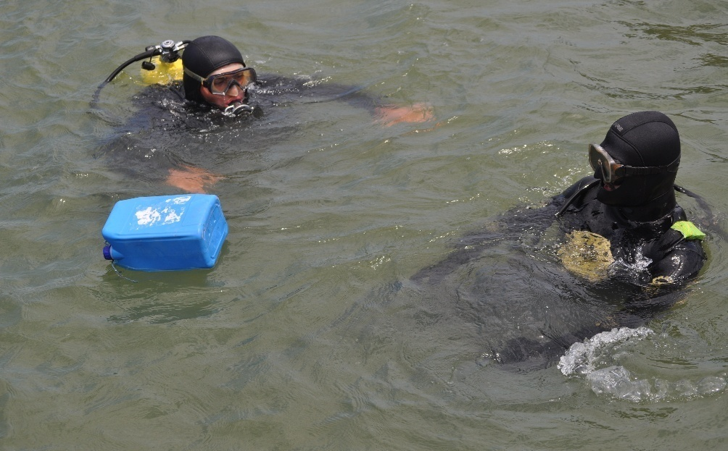 | 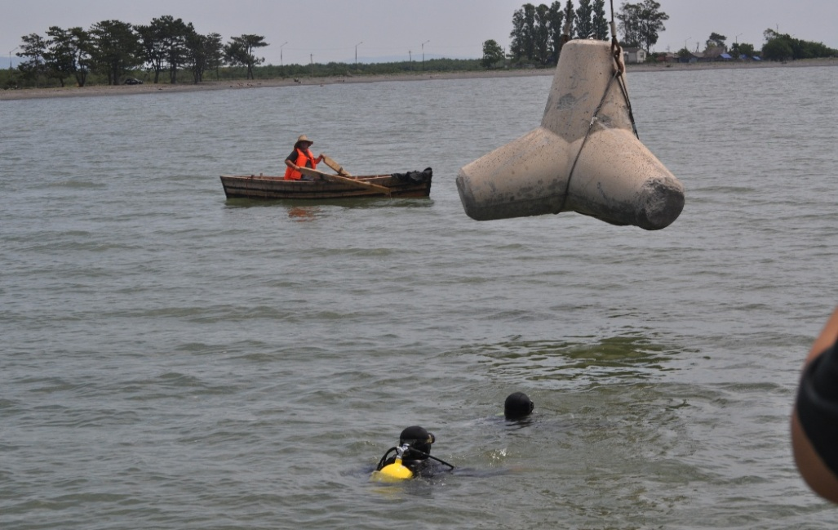
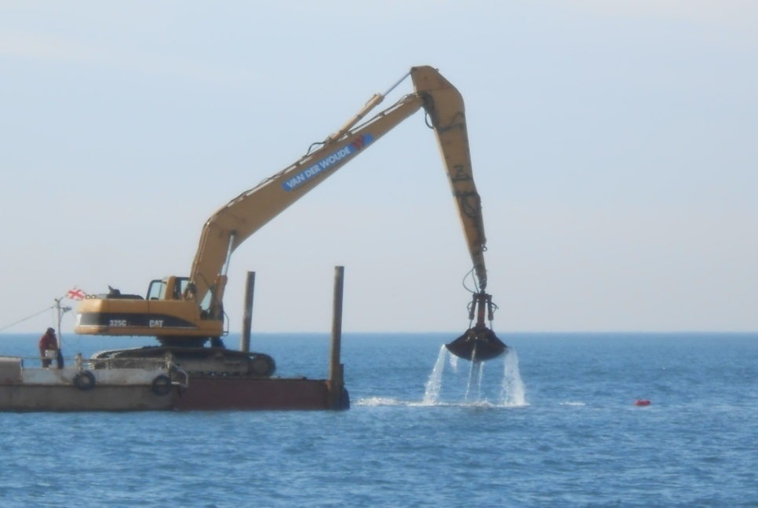 | 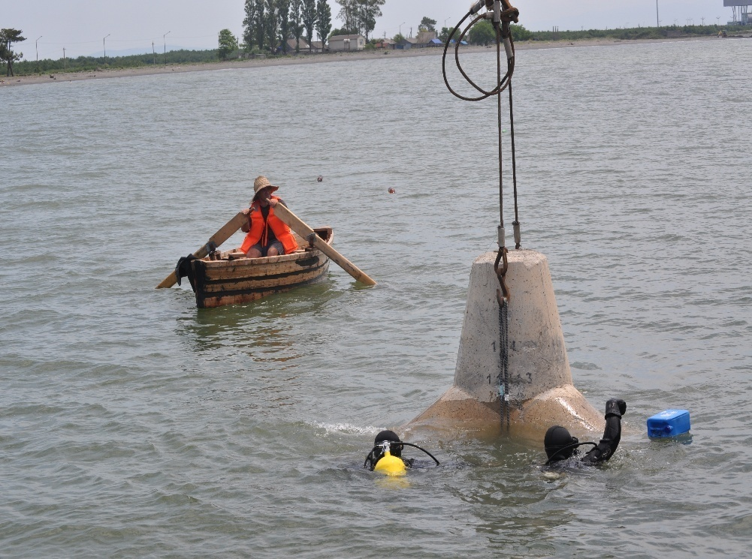

Implementation report on the environmental impact assessment (EIA)/initial environmental examination (IEE)/Site Specific Environmental Management Plan (SEMP) mitigation requirements

Reference | Requirement | Action to date | Action required/comment
Sea water pollution | The construction activities must be accomplished only in dry weather to avoid the pollution of the water currents;  The construction activities must be accomplished by observing relevant safety measures; the materials and waste must not be in uncontrolled way over the site, etc.  Locating the construction machinery and other equipment at a distance of at least 50 m from surface water bodies (where possible. If this seems impossible, taking permanent control and safety measures to avoid water pollution);  Prohibition of washing of vehicles and other machinery near surface water bodies - The vehicles and equipment are recommended to wash by using commercial washing services;  Limiting fueling and/or maintaining the vehicles/equipment to the specially designated places only;  The equipment and vehicles should be maintained in good working order to avoid the risk of spills of fuel/lubricants;  Expedient materials and waste management;  The waste generated during the works will be collected and temporarily stored at the specially designated places, distanced from the water bodies;  In case of fuel/oil spills, locating and spilt material and cleaning the polluted area immediately to avoid long soil pollution;  Installing drainage systems around the areas with the potential pollutants of surface flows (e.g. along the perimeter of groudn or construction materials storage areas);  Instructing the personnel on the environmental and safety issues. | All works has been accomplished only in dry weather working conditions.  All construction materials and machinery has been located 50 M away from surface of the water. All equipment and machinery has been maintained in good working conditions.  The construction waste has been accumulated in special designated areas away from the water bodies and removed buy authorized personal only.  On site environment specialists are maintaining visual monitoring for oils spills and equipment conditions, no accidents has been detected.  Working Personal is being instructed on environment and safety issues rules and regulations. | Monitoring of the Surface water mitigation level is been carried out by contractor environmental specialist on every day basis and by supervising environmental specialist  Regular check-up and inspection;  Laboratory control – as necessary (in case of oil spills). During reporting period no problems has been detected
Pollution of underground waters | Control for the Pollution of underground waters must be maintained in the areas like: Construction camp - Material and waste storage areas; Construction sites, Gas station.  Taking all measures to avoid the deterioration of the seawater quality. | All works has been accomplished only in dry weather working conditions.  All construction materials and machinery has been located 50 M away from surface of the water. All equipment and machinery has been maintained in good working conditions. The construction waste has been accumulated in special areas away from the water bodies and removed buy authorized personal only. On site environment specialists are maintaining visual monitoring for oils spills and equipment conditions, no accidents has been detected. Personal is being instructed on environment and safety issues rules and regulations. | Monitoring of the Surface water mitigation level is been carried out by contractor environmental specialist on every day basis and by supervising environmental specialist  Regular check-up and inspection;  Laboratory control – as necessary (in case of oil spills). During this period no problems has been detected
Noise | The equipment and vehicles should be maintained in good working order;  Driving the vehicles at optimal speeds;  Instructing the personnel (particularly, the drivers of vehicles and techniques);  Registering and responding to grievances (if any);  Driving the vehicles along optimal routes and at optimal speeds;  Switching off the vehicle drives or running at minimal speed when the vehicles are not used;  Carry out noisy operations during day time;  Reaching preliminary agreement with the population living near the road about particularly noisy works. | On site Environmental specialists are conducting visual control (on regular basis) of soil quality, laboratory control of soil quality (in case of spills) no oil spills has been detected, technical check-up of machinery. | Regular monitoring has been carried out to provide guaranteed protection of the underground water quality.
Dust | Watering of the non-asphalted ground or bare ground surfaces once in four hours on working days and in dry or windy weather;  Observing the rules for storing the fill construction material to avoid their dusting in windy weather;  Covering the lorries with tarpaulin when transporting loose materials, when there is probability of dusting;  Taking necessary precautions (e.g. avoiding throwing the materials from heights when unloading them) to avoid excess dust emission during the earthworks and loading and unloading the materials;  Driving the vehicles at optimal speeds;  Washing the vehicle tires (recommended to use commercial services for this purpose);  Instructing the personnel (particularly, the drivers of vehicles and techniques);  Registering and responding to grievances (if any);  Driving the vehicles along optimal routes and at optimal speeds;  Switching off the vehicle drives or running at minimal speed when the vehicles are not used. | All vehicles are maintained in good working conditions. Drivers are instructed to follow the limitations of driving speed (On construction site 10 km/h, 30 km/h on main roads). All noisy operations have been carried out during day time. No grievance has been detected concerning noisy works. | Monitoring of the construction process noise level has been carried out by contractor environmental specialist on every day basis and by supervising environmental specialist. Regular control (particularly during much “noisy”  operations);  Measuring (In case of grievance); During this period no grievance or problems has been detected.  Technical check-up of machinery before works. The nearest receptor (residential houses) is approximately 400-500 m away from construction site, drivers are maintaining the safe speed limits 30 km/h on main roads and 10 km/h on construction site, there for no noise complains has been detected.
Waste | Visual control of the area;  Control over the waste management.  Protecting soil and water quality;  Reducing the risk of negative visual impact;  No dissatisfied population. | Monitoring of waste management issues is being carried out by contractor environmental specialist on every day basis and by supervising environmental specialist.  Regular check-up and inspection;  Construction waste is accumulated on construction site in special isolated areas divided by hazardous, domestic and construction waste. Construction company has signed contract with the companies for waste removal. The waste is being removed from construction site buy authorized personal only in accordance of safety regulations. | On 02.07.2014 the domestic waste has not been removed on time, what was corrected on 03.07.2014.
Vibration | The equipment and vehicles should be maintained in good working order;  Driving the vehicles at optimal speeds, particularly in the settled areas;  Instructing the personnel (particularly, the drivers of vehicles and techniques);  Registering and responding to grievances (if any);  Driving the vehicles along optimal routes and at optimal speeds;  Switching off the vehicle drives or running at minimal speed when the vehicles are not used;  Carry out noisy operations during day time; | Watering of the roads has been carried out by the contractor on every day basis. All lorries have been covered buy tarpaulin to avoid dusting. Drivers are instructed to follow the limitations of driving speed (On construction site 10 km/h, 30 km/h on main roads). No grievance has been detected. | Monitoring of the construction process soil mitigation level (including dusting problems) is been carried out by contractor environmental specialist on every day basis and by supervising environmental specialist.  Regular check-up;  Inspection after completion of works;  Laboratory control – as necessary (in case of oil spills). Material and waste storage areas are indicated and isolated. During this period no problems has been detected.
Air Pollution of emissions | The equipment and vehicles should be maintained in good working order;  Driving the vehicles along optimal routes and at optimal speeds;  Switching off the vehicle drives or running at minimal speed when the vehicles are not used.  Instructing the personnel before the start-up of the works. | All vehicles are maintained in good working conditions. Drivers are instructed to follow the limitations of driving speed (On construction site 10 km/h, 30 km/h on main roads). All noisy operations have been carried out during day time. No grievance has been detected concerning vibration. | Monitoring of the construction process noise level is been carried out by contractor environmental specialist on every day basis and by supervising environmental specialist. Regular control (particularly during much “noisy” operations);  Measuring (In case of grievance); During this period no grievance or problems has been detected.  Technical check-up of machinery before works. The nearest receptor (residential houses) is approximately 400-500 m away from construction site, drivers are maintaining the safe speed limits 30 kph on main roads and 10 kph on construction site, there for no noise complains has been detected.
Disturbance of the seawater during installation of tetrapods | During the works to level the seabed, permanent seawater analyses are needed to identify the degree of the water turbidity;  If the degree of the water turbidity is in excess of the admissible limit (25 gr/l), the works must be stopped and relevant corrective measures must be taken. | Monitoring of the Increased seawater turbidity level is been carried out by contractor environmental specialist on every day basis and by supervising environmental specialist. Permanent visual control;  Identifying the degree of turbidity through analysis (in every 4 hrs. During the work). Upon intensive commencement of works in the sea, water testing has been conducted together with turbidity control, no problems has been detected. | During installation of TTP units environmental specialists are conducting visual control, taking turbidity analysis. No increased seawater turbidity has been detected.
Labor safety | Site -Inspections;  Availability of personal protection equipment and periodic control over their good maintenance;  Control over the meeting the requirements for labor safety.  Ensuring compliance with health and safety norms;  Avoiding/minimizing traumatism. | Monitoring of the labor safety issues is being carried out by contractor’s environmental specialist on every day basis and by supervising environmental specialist. Before the works; Periodic control during the works. Some of the labors don’t have PPE equipment. | On 14.08.2014 delay of damaged (used) PPE equipment replacement for the stuff. Corrected on 18.08.2014.  On 28.10.2014 one of the staff members did not have safety equipment and uniform on site. Corrected on 29.10.2014.

